

**Crombie School**

**Early Learning and Childcare**

**Benefit Risk Assessment Policy**

**POLICY AIM**

The benefit Risk Assessment Policy has been developed in line with The United Nations Convention of the Child (UNRC) (1989): The United Nations Convention on the Rights of the Child (UNCRC) – (1989):

***Article 3****: (Best interests of the child): The best interests of the child must be a top priority in all things that affect children.*

We aim to ensure that the Benefit Risk Assessment procedures are fair, equitable and responsive to each individual case, meeting the following Health and Social Care Standards:

|  |
| --- |
| ***1.25*** *I can choose to have an active life and participate in a range of recreational, social, creative, physical and learning activities every day both indoors and outdoors.*  ***2.24*** *I make informed choices and decisions about the risks I take in my daily life and am encouraged to take positive risks which enhance the quality of my life.*  ***3.25*** *I am helped to feel safe and secure in my local community.*  ***5.17*** *My environment is secure and safe* |

|  |
| --- |
| The Benefit Risk Assessment Policy is underpinned by the following national and local authority policy and guidance:   * Health and Safety Executive ,2014, “Risk assessment. A brief guide to controlling risks in the workplace. (leaflet INDG163 (rev4))” * Care Inspectorate, 2016, “My World Outdoors” * United Nations Convention on the Rights of the Child, 1989 * Scottish Government, 2017, Health and Social Care Standards My support, my life * Education Scotland, 2016, How Good is our early learning and childcare? * Health and Safety Executive, 2012(19), “Children’s Play and Leisure – Promoting a Balanced Approach." * Play Safety Forum, 2012, (second edition),” Managing Risk in Play Provision: Implementation guide” * Aberdeenshire Council, 2010, "Aberdeenshire Council Risk Assessment Guidance" |

**Who is responsible?**

Head Teacher, Early Years Senior Practitioner, Early Years Lead Practitioner, Nursery Staff

***This policy will be reviewed regularly and in response to accident, incident or change in national or local policy or guidance***

**PROCEDURE**

At Crombie Nursery, we are committed to supporting children in accessing risky play, safely.

“***As children and young people develop, they need to try and learn new things and learn new skills. They need to work out risks for themselves as part of their learning process.” Care Inspectorate 2016-My World Outdoors***

We believe a Benefit Risk Assessment procedure can contribute to the quality and effectiveness of the service. This policy statement sets out a procedure for staff to assess risk and the benefits for children to receive high quality care and experiences.

* Benefit Risk Assessments are carried out to establish what needs to be carried out to keep all parties involved safe, whilst thinking about the benefit of the activity.
* A Benefit Risk Assessment will look like image below.

|  |  |  |  |
| --- | --- | --- | --- |
| **Department : Education**  **CROMBIE PRIMARY SCHOOL AND NURSERY** | **RISK ASSESSMENT** |  | |
| **Location/Activity: MARK MAKING AREA**  Using various Items to Mark Make | | **Location:** Crombie Primary School | |
| **Assessment carried out by:** Diane Booth **Signature:** | | | **Date**: July 2019 |

|  |  |  |  |  |  |  |  |  |  |  |  |
| --- | --- | --- | --- | --- | --- | --- | --- | --- | --- | --- | --- |
| **Benefits** | **Hazards** | **Risk** | **Level of Risk**  **S X L = RR** | | | **Level** | **Control Action** | **Level of Risk**  **S X L = RR** | | | **Level** |
| Fine Motor skills  Independence  Perseverance  Imagination  Social skills  Pre Literacy  Numeracy | Small Items/Objects | Swallowing small items or placing in nose/ears. | 3 | 3 | 9 | M | * Adult supervision. * Rules for using small items reinforced regularly. * Careful and considered choice of items by staff. | 2 | 2 | 4 | L |
| Scissors | Minor injury/ Cuts | 3 | 3 | 9 | M | * Adult supervision. * Rules for using scissors reinforced regularly. * Round nosed scissors will be used by children. * All equipment will be stored in a safe manner (including adults’ scissors) | 2 | 2 | 4 | L |
| Stapler | Minor injury/ Cuts | 3 | 2 | 6 | M | * Adult Supervision | 2 | 2 | 4 | L |
| Glue Sticks | Ingestion | 3 | 3 | 9 | M | * Adult supervision.   Rules for using glue sticks reinforced regularly. | 2 | 2 | 4 | L |

Competed by: Diane Booth

Review Date: 2019/2020 ü (17.7.20)

* The level of risk ***before*** measures are put in place and ***after*** are assessed. These are worked out using Severity of Risk x Likelihood of Risk = Relevant Risk

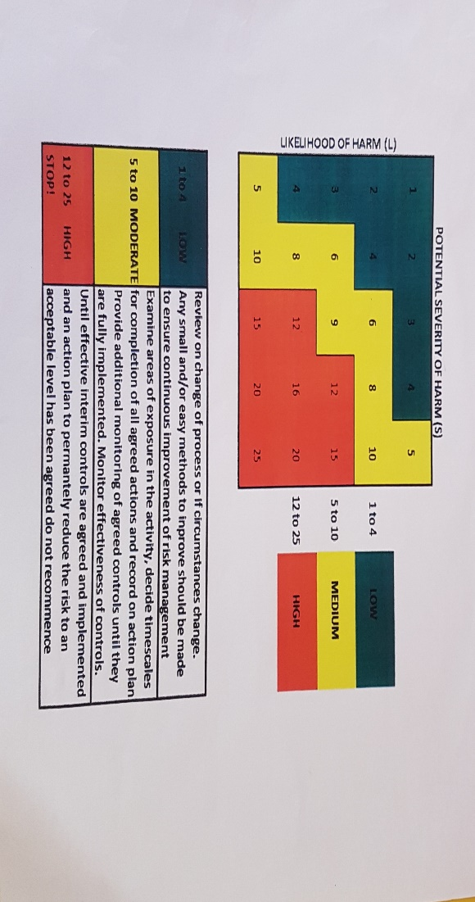

* The measures are then put in place and the Risk Level is reduced.
* The Risk Level may not reduce after measures in place however, but as long as measures are there, and the EYSP feels that the benefits outweigh the risks, the activity can still go ahead.
* A Risk Assessment will be written specific to the activity for a ‘one off, or unique activity.
* Consideration of the natural environment and location is considered for outdoor activities.
* An EVOLVE online form will be filled out for any activity that takes place out with the school grounds. This is approved by the Head Teacher or other authorised staff members
* Children will be fully involved in some of the Risk Assessment process.
* Risk Assessments will be taken into consideration any children with additional support needs.
* Risk Assessments will be reviewed and updated annually and as and when required.
* Please refer to separate Policy for Excursions.

**References**

Health and Safety Executive 2014, “Risk assessment. A brief guide to controlling risks in the workplace. (leaflet INDG163(rev4), ”

<http://www.hse.gov.uk/pubns/indg163.pdf>

Care Inspectorate, 2016, “My World Outdoors”

<http://www.careinspectorate.com/images/documents/3091/My_world_outdoors_-_early_years_good_practice_2016.pdf> page 18

Health and Safety Executive, 2012(19), “Children’s Play and Leisure – Promoting a Balanced Approach’’ <http://www.hse.gov.uk/entertainment/childrens-play-july-2012.pdf>

Aberdeenshire Council, "Aberdeenshire Council Risk Assessment Guidance", 2010 <http://arcadialite.aberdeenshire.gov.uk/risk-assessment-guidance/>  Arcadia Risk Assessment Guidance

Aberdeenshire Council, <https://evolve.edufocus.co.uk/evco10/evchome_public.asp?domain=aberdeenshirecouncil-excursions.org.uk> – EVOLVE risk assessment log in

Play Safety Forum, 2012(second edition), “Managing Risk in Play Provision: Implementation guide”

<http://www.playscotland.org/wp-content/uploads/Managing-Risk-in-Play-Provision-implementation-guide-2nd-edition-2.pdf>

United Nations Convention on the Rights of the Child, 1989 <https://www.unicef.org.uk/what-we-do/un-convention-child-rights/>

Scottish Government 2017, Health & Social Care Standards, My support, my life.

<https://www.gov.scot/publications/health-social-care-standards-support-life>

**Date of original policy** **July 2020**

|  |  |  |  |
| --- | --- | --- | --- |
| **Revision Number** | **Details of Change** | **Date** | **Date of next review** |
| 1 | Full review of procedures | July 2020 | July 2021 |
| 2 | Policy Update | October 2020 | August 2021 ü |
| 4 | Policy Update |  |  |
| 5 |  |  |  |
| 6 |  |  |  |
| 7 |  |  |  |

**Policy Author** Diane Booth EYSP

**Read by Staff:**

|  |  |  |  |
| --- | --- | --- | --- |
| **Staff Name** | **Date & Initial** | **Date & Initial** | **Date & Initial** |
| Adele Dickson |  |  |  |
| Claire Hawthorne |  |  |  |
| Diane Booth | **16/10/20 DB** | **30.07.21 DB** |  |
| Elizabeth Duffy | **08/04/21 ED** | **13/08/21 ED** |  |
| Denise Jamieson |  |  |  |
| Jamie Finnie |  |  |  |
| Mary Olszewska | **09.04.2021 MBO** | **03.08.2021**  **MBO** |  |
| Gemma Bremner | **6/7/21 GB** |  |  |
| Lesley Robinson |  | **03/08/21 LR** |  |
|  |  |  |  |
|  |  |  |  |