,

**Welcome to**

**Crombie Nursery!**

**2020 – 2021**

## Handbook and Calendar

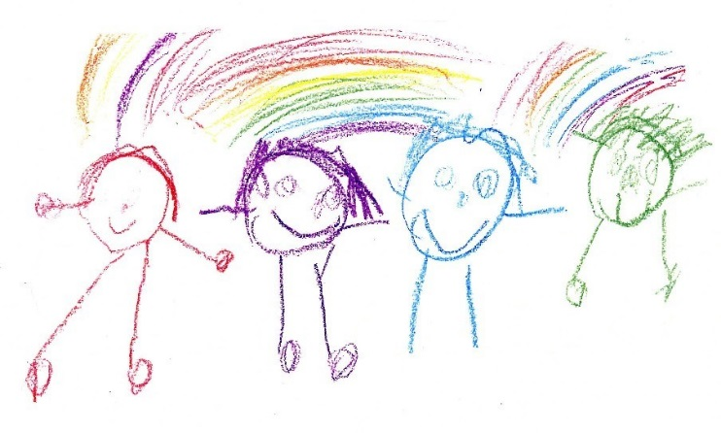

**Welcome to Crombie Nursery!** We are sure that you will be happy here.

At Nursery we will help you to learn new things through lots of fun activities. There will be lots of new and exciting things for you to do and you will make lots of new friends.

Sometimes our activities are messy, some take place indoors and some outdoors. In order to take part in all these exciting activities, you will need to bring some special things to Nursery each day.

**You will need:**

**An apron**

* ****Fabric aprons with long sleeves are best as they keep you warm in winter and are more comfortable than plastic ones. We sell these in school and can be bought from the office, although you can bring your own one if you prefer.

**Gym shoes**

* 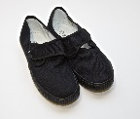We currently won’t be changing our shoes when we arrive in nursery, unless it is really wet outside, however, you will need to bring a pair of indoor shoes to Nursery. A pair of slip on gym shoes, or Velcro strapped trainers are fine – laces can be a bit tricky so try to avoid these, please.

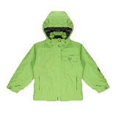**A coat, hat, gloves, and waterproof suit**

* We play and learn outside as much as possible, in all weathers, so please bring a suitable coat, hat and gloves to Nursery every day so that you can take part. If possible, a waterproof suit to stay in nursery. We can allocate one of our nursery suits if need be. Please speak to a member of staff.

[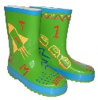](https://www.google.co.uk/url?sa=i&rct=j&q=&esrc=s&source=images&cd=&cad=rja&uact=8&ved=0ahUKEwixx_absOfTAhWFvBoKHTM1A38QjRwIBw&url=https://www.wellieart.co.uk/Little-Pals-Childrens-Paint-Your-Own-Wellies.html&psig=AFQjCNHFJDLME_xLFQ1Q8KvUjCltlrw8Yw&ust=1494576160806435)**Wellies**

* We play and learn outside as often as possible, in all weathers, so please

bring a pair of wellies, clearly labelled with your child’s name, to **stay** in nursery.

**A Nursery backpack**

* 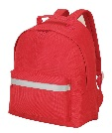You will need a backpack to carry your apron, change of clothes and shoes to Nursery. When you get here you will be given a peg to hang your bag on. This will currently stay in nursery at all times. Please do not bring any toys from home, however an exception will be made if it is necessary to help to settle your child in.

There are lots of boys and girls in our Nursery, who often have the same things as you, so **please remember to put your name on everything**!

When you come to Nursery you will be given your own named peg for you to hang your bag and coat on.

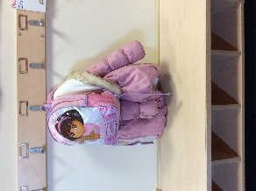

We hang our coat and bag here.

We keep our outdoor shoes in here.

**Nursery Times**

**Red Nursery: Monday 8.45am – 11.55am Thursday 12.20pm – 3.30pm**

**Tuesday 8.45am – 11.55am Friday 12.20pm – 3.30pm**

**Wednesday 8.45 – 11.55am**

**Blue Nursery: Monday 12.20pm – 3.30pm Thursday 8.45am – 11.55am**

**Tuesday 12.20pm – 3.30pm Friday** **12.20pm – 3.30pm**

**Wednesday 12.20pm – 3.30pm**

The main nursery door will be open for a longer period during this time to offer a flexible drop off and pick up to minimise the contact between adults, therefore you can drop off and pick up between these times.

**AM- Drop off 8.30am – 9.15am AM – Pick up 11.30am – 12.00pm PM – Drop off 12.10pm – 12.50pm PM – Pick up 3.00pm – 3.30pm**

Adults will **NOT** be allowed in the setting to drop children off, therefore adults should meet a member of staff at the main nursery door, where they will sign your child in. The same procedure applies for picking your child up at the end of the session.

**All adults dropping off or picking up pupils must please adhere to the 2m social distancing rule when in the school grounds.**

Extra handwashing will be routinely done throughout the day at designated times, as children enter nursery, before snack, after using the toilet, moving between areas (indoors/outdoors) and any other occasions that arise.

All surfaces will be cleaned every 2 hours during the day by staff and resources will be cleaned between each session and where possible, resources will not be shared between different groups of children.

Risk Assessments are in place and will be reviewed regularly following the most up to date Government Health Guidelines. This is available if anyone wishes to view it, please ask a member of staff.

**Snack**

We have a small snack every day. This will be prepared freshly by staff to help with this. We always have fresh fruit or vegetables to offer, alongside our snack of the day. There is a choice of milk or water to drink. STAFF WILL SERVE CHILDREN THEIR SNACK, THERE WILL BE NO SELF-SERVICE SNACK. We won’t ever make children eat anything you dislike, but we encourage them to try a little bite of all the foods at Nursery. Water will always be available throughout the day. Snack fees will be issued at the beginning of a term.

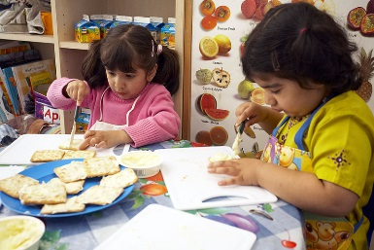

**Sample Menu**

|  |  |  |  |  |  |
| --- | --- | --- | --- | --- | --- |
| **Week** | Monday | Tuesday | **Wednesday** | **Thursday** | Friday |
| 1 | Bagels and soft cheese  Bananas and plums | Muffin Pizza  Cucumber and tomatoes | Crackers  Cheese cubes  Apples | Spaghetti hoops and toast  Melon | Scone and butter  Grapes |
| 2 | Breadsticks  Vegetable sticks  Dip | Fish finger wraps  Cucumber and tomatoes | Carrot Muffins (made in nursery)  Melon | Tomato Soup and bread  Fruit | Toast and butter  Fruit |
| 3 | Banana Pancakes  Mixed berries | Breadsticks & Dip  Cucumber, lettuce and peppers | Rice cakes  Dried fruit | Cheese sandwiches  Grapes  Pears | Vegetable cous cous  Apples  Water melon |
| **4** | Oatcakes and cheese Tomato and cucumber | Crumpets  Oranges  Melon | Banana Bread  Apples  Plums | Buttered Muffins  Cucumber and peppers | Tuna Sandwiches  Grapes |



**Things to remember……**

* If it’s a sunny day, take a sun hat to nursery with you.
* If it’s a sunny day please apply sun cream **before** you come to nursery. Please also provide a bottle of sun cream, clearly marked with your child’s name to keep in their nursery bag.
* Please remember to label all items of clothing and shoes with your name.
* A spare change of clothing can be useful to have in a bag, on your peg.
* Please remember that the car park is only for STAFF cars, this is a health and safety issue and we thank you for helping us with this.

**Crombie Nursery staff are always happy to meet with parents or carers. If you have any concerns, please speak with a member of our team.**



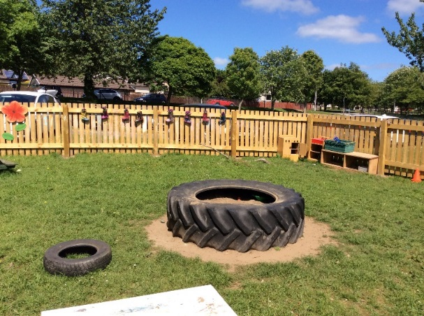**This is what the children at Crombie have to say about their time in our Nursery…..**

“I like playing on the swing on the tree.”

“I like climbing trees.”

“We get to take pictures on the Ipad.”

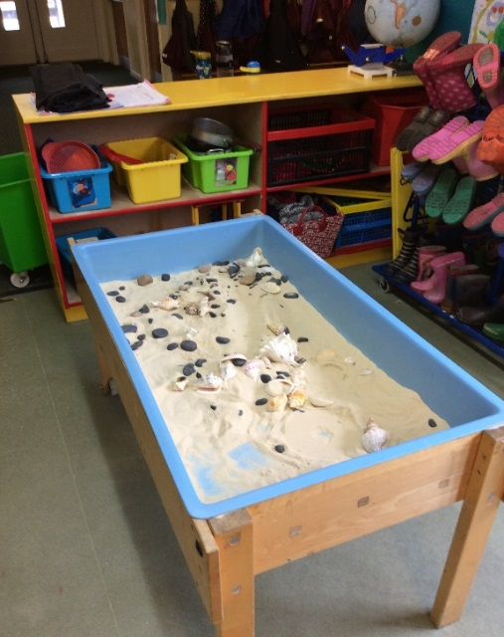

“You can do drawing and painting.”

“I like playing the farm game on the Smart Board.”

“You get to play outside with dinosaurs!”

“We have a house with a sofa and play cats.”

“I like the number game that goes to 100.”



**Crombie Nursery**

We look forward to meeting you!

The Early Years Team ☺